Unit 1: Lesson 2
Thinking, Doing, & Feeling Good!

Goal: To learn that thoughts, actions, and feelings work in a circle. This model explains that we feel good about ourselves when we do positive actions.

Story:
A warm, spicy smell drifted into his bedroom. “Cinnamon French Toast! What a great day!” Sam thought. He dashed downstairs and gave his dad a big bear hug. His dad grinned and handed him a plate of French toast.

Then Sam thought, “I had such a good day yesterday. I got a good grade on my science test. I’m going to make it another great day! I’m going to have some fun today; I can’t wait to see my friends. I really feel like working hard, too.”

Sam did make it a great day. He scored well on his math test, made a new friend, and even made all of his free throws at his basketball scrimmage. A few problems came up during the day, but Sam handled them well. He felt great about himself and his life, and he went to bed happy.

A few mornings later Same groaned to himself, “I’m too tired to get up. What an awful way to start the day.” He was already late when he stumbled into the bathroom. His hair was plastered to one side of his head, and it stuck out straight on the other. Try as he would, he just couldn’t make it go where he wanted it to. “What bad hair,” he thought. “Nothing is going to work out right today, I just know.”

And he was right. For breakfast Sam found a slice of three-day-old pizza in the fridge. He ate an anchovy before he realized it was there. Ugh! He hates anchovies. He dozed off in science (the class he had been trying so hard in), got caught teasing some students at lunch and missed every basket in the basketball scrimmage. He had problems everywhere. In fact, his whole day was one big problem. At home he fought with Anne Marie and wound up watching TV for three solid hours instead of doing his homework. He refused to talk to anyone. Sam went to bed feeling very unhappy.

Sam started out the first day with a positive thought: “I’m going to make it another great day!” That positive thought led to positive actions. And those positive actions helped Sam feel good about himself.

We call this process the Thoughts-Actions-Feelings Circle. The Thoughts-Actions-Feelings Circle is a model that explains the main idea of the Positive Action program: We feel good about ourselves when we do positive actions.

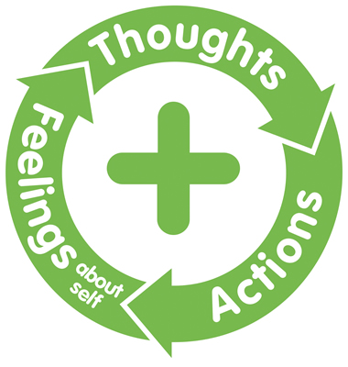

This is the positive side of the Thoughts-Feelings-Actions Circle. This is known as the Happy Circle.
It simply states that we have a positive thought that leads to a positive action. That positive action leads to a positive feeling about ourselves. That good feeling leads us to choose another positive thought and put it into action. Each time we choose a positive thought that leads to a positive action, we feel good about ourselves: our self-concept grows even more positive.

Happy Circles are fun to be in. When we’re in the Happy Circle, we like ourselves and other people. We feel good about who we are and what we’re doing. We do good things with our days.

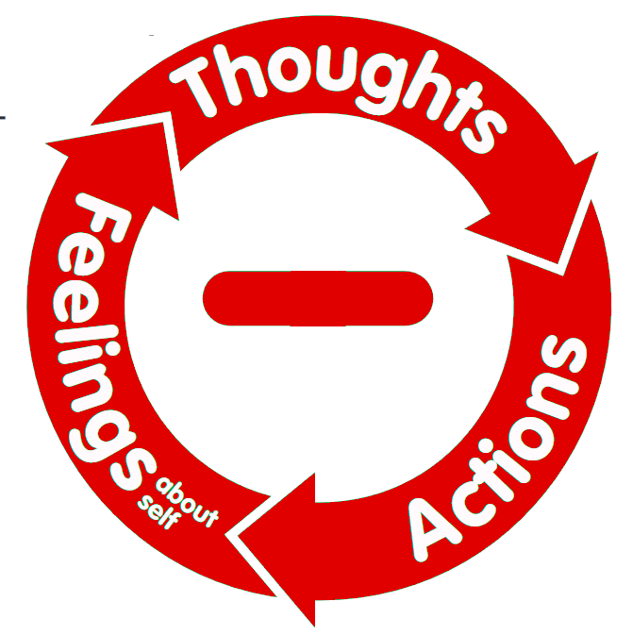
This is the negative side of the Thoughts-Actions-Feelings Circle. This is the Unhappy Circle.
We know how the Happy Circle works. Unfortunately, the Unhappy Circle works in the same way. Think back to our story at the beginning of the lesson. Sam started the Unhappy Circle as soon as he thought, “What an awful way to start the day.” From that point on, nothing went right for him. He thought negative thoughts, did negative actions, and felt negative about himself.
When we choose to act on negative thoughts, then we do negative actions, which make us feel bad about ourselves. When we choose positive thoughts, then we do positive actions, and we feel good about ourselves. In the Thoughts-Feelings-Action Circle we are either moving forward or we’re sliding backward. There is no middle! We’re either building a positive self-concept or a negative self-concept.
Not only do our lives improve when we are in the Happy Circle, but the lives of those we affect become positive, too. We can affect others in positive ways or in negative ways.
You don’t have to worry if you are in the Unhappy Circle. You don’t have to stay there. You can stop it. You can turn it around to the Happy Circle! You can use positive thoughts to interrupt a negative circle. Then we can do positive actions that will turn the negative circle into a positive circle.
We get to decide which circle we want to be in. Our self-concept is up to us. Let’s think positive thoughts, do positive actions, and feel good about ourselves!
Questions:
How does the Thoughts-Feelings-Actions Circle affect our self-concept?
How do our thoughts affect our actions?
How do our actions affect our feelings about ourselves?
How do we interrupt an Unhappy Circle?

Discussion (Think about how these questions affect you individually and as a family):
- What is an example of a Happy Circle in your life?
- What is an example of an Unhappy Circle in your life?
- How do you feel about yourself when you are in a Happy Circle?
- How do you feel about yourself when you are in an Unhappy Circle?

Plan:
Plan to create a Happy Circle this week, starting with a positive thought. For example, “I like my family,” or “I’m happy at home,” or “I’m proud of my work.”
Then choose a positive action that follows that thought. Maybe you will write a note to your family members telling them how much you like them. Maybe you could give extra effort to a project. Then take a few minutes to realize how you feel about yourself when you do the positive actions.
Parent Positive Actions
Ask Yourself: What are some examples of a Happy Circle you are experiencing as a parent? How can you change your Unhappy Circle into a Happy Circle? What are some ways you can teach the Thoughts-Actions-Feelings Circle to your children?
Plan and Do: Throughout the week, watch for the Thoughts-Actions-Feelings Circle. When you see an Unhappy Circle developing with yourself and your children, find ways to interrupt the Unhappy Circle with a positive thought and action and turn it into a Happy Circle.
Help create Happy Circles for yourself and your children, starting with positive thoughts, doing positive actions, and enjoying the good feelings that come as a result. Help your children start Happy Circles on their own. Reinforce the Happy Circles you see with yourself and your children all during the next week.

We don’t have to just keep the Happy Circle in our own families. Let’s share the Happy Circle idea with people in our community. We can do this in many ways, for example by just telling people, by writing notes, or by baking cookies. Help people to know that you are trying to help them have a positive self-concept.
This week let’s also watch for the circle at work in our community and reinforce it. If you see people in your community expressing a positive thought, or see others doing positive actions, you can reinforce those positive experiences by thanking them or commenting on the good thing they are saying or doing.

This week let’s remember the main idea of the Positive Action Program: We feel good about ourselves when we do positive actions. The Thoughts-Actions-Feelings circle can be positive or negative. We can choose which circle we want to be in. If we find ourselves in an Unhappy Circle, we don’t have to stay in it. Interrupt it! Happy Circles are fun to be in!

Word of the week: Self-Concept
How you think and feel about yourself.

